Identify Mathematical Expressions to Generate Voltage Sag and Swell Waveforms with User-Defined Sag and Swell Percentages

Rishi Kant Arya  
 *Electrical Engineering*  
 *Indian Institue of Technology* Palakkad, India  
122001041@smail.iitpkd.ac.in

*Abstract*— Voltage sags and swells are very common issues in power system that can cause significant problems in electrical systems which can result in equipment damage, production downtime, and safety hazards. To better understand these phenomena and their impact, the power system engineers and researchers often use mathematical expressions to generate voltage sag and swell waveforms with the user-defined percentages. This approach is very useful for testing and developing power quality mitigation strategies and equipment, such as voltage regulators and uninterruptible power supplies are tested under different sag and swell scenarios to check their effectiveness in mitigating these disturbances. The mathematical expressions used for generating these waveforms are typically based on the sine function, and adjustments in the values of time interval, frequency, percentage of sag or swell and nominal or normal voltage can create different types of sag and swell waveforms. These waveforms can be used to simulate various power quality events or disturbances and test the response of electrical equipment under different scenarios and contribute in the progress of power quality education.

Keywords— Power Quality, mitigation, power quality disturbances, Sags and Swells.

# Introduction

The issue of power quality problems or disturbances is a key area of interest in the smart grid field and power quality education, and various algorithms have already been developed to analyze and study these problems. Many Researchers have developed various methods based on the analysis of time-domain, frequency-domain, and time-frequency domain and the verification methods for these algorithms are based on mathematical expressions of the disturbance waveform and it uses the appropriate value given by the researchers to analyze a particular type of fault in the power system. Some of the common methods are using Fast Fourier Transform, Zero crossing detection, using some elementary functions and many more. In this paper we will try to analyze the two very common types of disturbance in the power system which results in voltage sag and voltage swell. We will try to generate the voltage sag and swell waveforms in a GUI created by python programming in which we will ask the user for various parameters like percentage sag and swell, frequency of the waveform, duration of sag and swell and its amplitude. These waveforms will be generated using the elementary functions such as sine and unit step functions. These waveforms can then be analyzed for the study of the actual power systems by correlating them and thus we will be able to understand the effect of various system parameters on the power quality in depth and try to make a counterpart to suppress the effect.

# Materials and METHODS

## Concepts:

Voltage sag is a short duration phenomenon in which there is reduction in the RMS voltage. It is observed when the RMS voltage is reduced between 10 to 90% of nominal or normal voltage. It can remain there for a half cycle or for few seconds. Whereas, in Voltage swell the RMS voltage is increased by 10 to 90% for the same amount of duration as the voltage swell. If the sag or swell lasts for longer duration then it is called sustained sag or swell respectively. Generally, they are caused due to short circuit in the system or because of sudden increase or decrease in the heavy load like furnace, motors, etc.

By using some elementary functions, we can generate the voltage sag and swell waveforms, which are:

X1(t) = A*[1 − ∝(u(t − t1) − u(t − t2))]*sin (wt) (1)

where, X1(t) is the sag voltage, ∝ is the percentage of sag the user want, u(t) is the unit step function, t1 and t2 are the start and end time of the sag and sin(wt) is the sine wave having w as the angular frequency.Similarly, the swell voltage waveforms can also be generated which is given by:

X2(t) = A*[1 + ∝(u(t − t1) − u(t − t2))]*sin (wt) (2)

Whereas here, X2(t) is the swell voltage, ∝ is the percentage of swell the user want, u(t) is the unit step function, t1 and t2 are the start and end time of the swell and sin(wt) is the sine wave having w as the angular frequency. Note that, f is the frequency of the voltage wave which is given by user and is related to angular frequency ‘w' as:

w = 2 π f (3)

## Proposed Method

As we have to plot the sag and swell waveforms we need to first write the code in Python and our method starts from there.

Figure 1: Block diagram of the proposed method to plot sag or swell waveform

Step1: We imported various libraries which were required for our program like numpy, matplolib.pyplot and math.

Step2: We declare the required variables like amplitude, frequency, sag and swell percentages, its start and end time

And ask the user for its value.

Step3: We define the unit step function which we will use in the expressions of voltage sag and swell and also these two function inside the tkinter GUI.

Step4: Using the tkinter library of python we create a GUI in which we will ask the above user input and the plot the resultant waveforms.

Used equation are equation (1) and (2) only which is already expressed.

# Results and Section

For the test cases given:

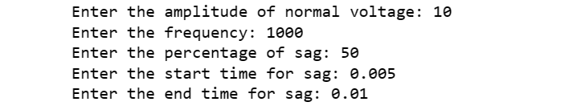

We got the output as shown below:

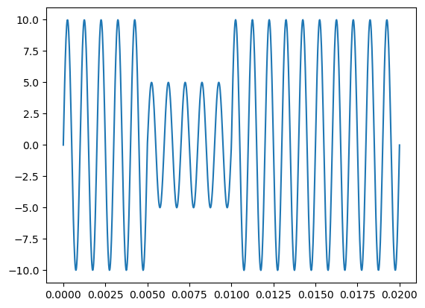

Where the x axis is the time and y axis represents the voltage and we can clearly see that the sag is occurring and ending at the input time interval with the required input sag percentage.Similarly, for the swell waveform the user input is given as:

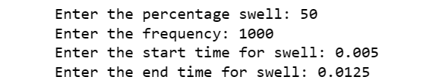

And the resultant sag voltage is shown below,

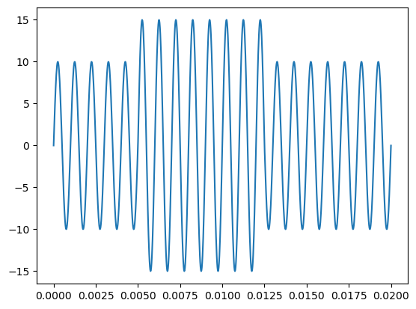

It can be clearly seen that the voltage swell starts and end at the given input time with the input parameters.

IV. CONCLUSIONS

We successfully plotted the required sag and swell voltage waveforms by taking the inputs from the user by writing a python program and making a GUI using it though I had some problem creating it which I managed to fix it and plot the waveform correctly. So, these waveforms of sag and swell are generally created due to various faults in the system and by creating it by own we can study the changes due to various parameters on the power system. In conclusion, the use of mathematical expressions to generate voltage sag and swell waveforms is an important tool in power quality research and engineering. These waveforms provide a way to study and test the effects of different power quality events on electrical systems and equipment, and can help in the development of more effective mitigation strategies.

##### Acknowledgment

First of all, I would like to thank our course instructor who helped me in doing the project work by explaining the work required and how we can achieve them. I would also thank the TAs of the course who were very helpful throughout the work and I am also very thankful to the author of all the resources which I have used for this project which are mentioned in the next section.

##### References

[1] HEYDT G T, FJELD P S, LIU C C, et al. Applications of the window FFT to electric power quality assessment. IEEE Transon Power Delivery, 1999, 14(4): 1411-1416.

[2] Hadi S (2004) Power System Analysis, 2nd edn, McGraw Hill.

[3] L. Hao, Q. Wei-Feng, S. Chang-Qing and L. Hong-Bin, "The Multiple Power Quality Disturbance Classification Based on Power System Time Domain Analysis," 2015 Sixth International Conference on Intelligent Systems Design and Engineering Applications (ISDEA), Guiyang, China, 2015, pp. 867-870, doi: 10.1109/ISDEA.2015.219.